

Order quoting module

Documentation

V3.0

Document Released: November 26, 2015

frePPLe bvba  
Woluwestraat 17  
1930 Zaventem  
http://frepple.com

**Table of Contents**

1. Introduction 3

2. User guide 4

a. Order quoting screen 4

b. Execution screen 5

3. Business processes and workflows 7

a. Entering of the order quotes 7

b. Plan release 8

c. Treating high priority orders 8

d. Reservation and allocation workflows 9

4. Architecture 11

5. Configuration 11

# Introduction

This document describes the order quoting module of frePPLe.

When receiving a new order or a quote traditional ERP systems will promise a delivery date that is based on the inventory of the end product and/or a fixed lead time. For make-to-order environments with complex capacity and material constraints this will result in infeasible or extra-conservative delivery dates being promised to your customers.

FrePPLe’s order quoting module performs a capable-to-promise check which allows you to obtain much more accurate and reliable delivery dates. It performs an on-line check of all available stock, capacity and raw material availability. The promise date it computes considers all material, capacity and time constraints.

Features:

* Capable-to-promise check across all levels in the bill of material.
* Returns the earliest feasible delivery date for the complete quantity, or can also propose partial shipments.
* In case the delivery date requested by the customer isn’t feasible, the module also returns the reasons why this is the case.
* Very fast reply in less than a second through a memory-resident planning engine.
* The module can be used from a screen in the frePPLe user interface.
* It is also possible to access the functionality as a web service. This allows the due date quoting functionality to be accessed on-line by other systems.

# User guide

## Order quoting screen

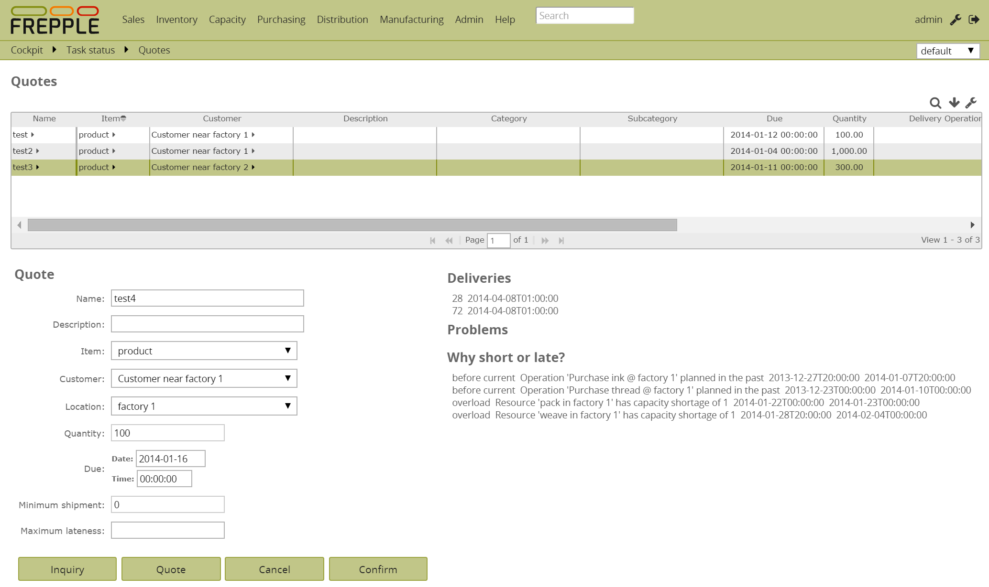

The order quoting screen has 3 sections:

* **Order quote list**The top section lists all demands of type “quote”. When a record is selected, its data are filled in the form.
* **Quote data form**In this section the information about a quote or inquiry are typed in.

The buttons at the bottom perform the following actions:

* + **Inquiry**:   
    Sends the entered information to the quoting service and displays the feasible delivery date.  
    *An inquiry doesn’t keep any material or capacity reserved*.   
    It is thus possible that other orders use up that supply, and the returned delivery date is no longer feasible when the order is finally confirmed.
  + **Quote**:  
    Send the entered information to the quoting service and display the results.  
    *A quote keeps the material and capacity required to achieve the replied delivery date are reserved while the quote is open*.   
    This means that no other quote or inquiry can use the same supply. This guarantees that the delivery date is still feasible when the order is confirmed later on. Only when the quote is canceled does the supply get released.
  + **Cancel**:  
    Completely removes the selected quote or inquiry.
  + **Confirm**:  
    Moves the status of the selected quote or inquiry to an open sales order.   
    This removes the line from the top section.  
    Note that the order still needs to be entered or updated in the ERP system as well.
* **Quote response**  
  This section is populated by the system after clicking the “inquiry” or “quote” button.

## Execution screen

The execution screen has 2 extra tasks:

* **Bringing up the order quoting service**  
  The start the order quoting service, the option “keep active in memory” needs to be marked when your generate the plan.  
  When the service is active, the task status will show:
  + The status is marked as “100%” when the new plan is completely exported to the database.
  + The message “order quoting service active” is displayed when the order quoting is up and running.
  + Note that the finish date remains empty. Only when the service shuts down will the finish date be filled in. The status will then change to “done” as well and the message field will be cleared.

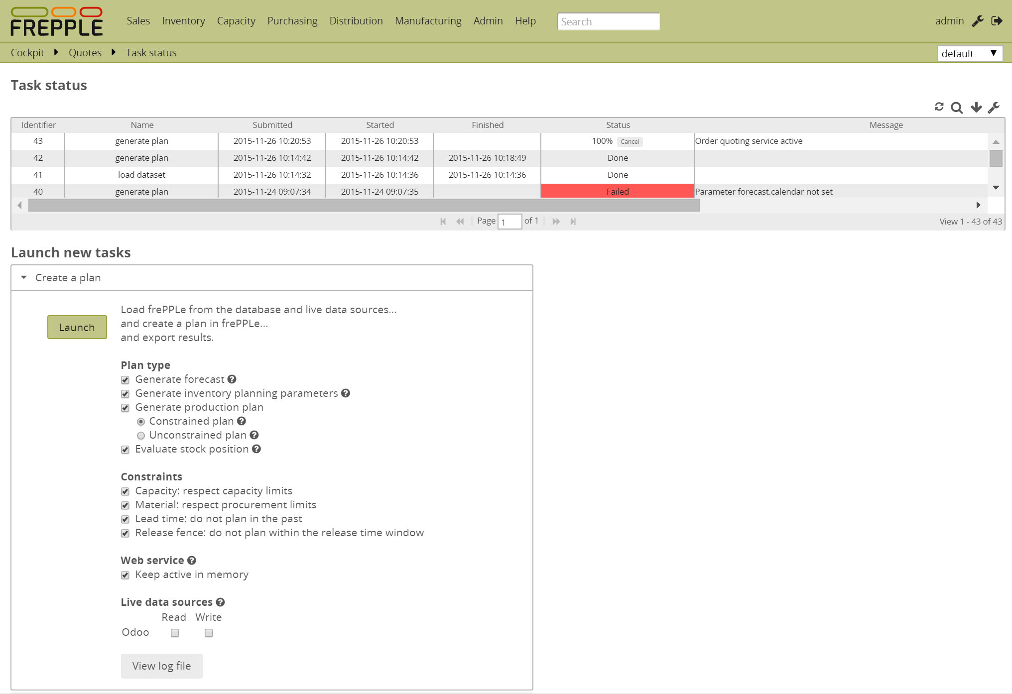

* **Shutting down the order quoting service**   
  An extra section is added to the list of possible tasks. Clicking the button there shuts down the service if its running.  
  Note that the service is also shut down when you rerun the plan. In most cases there is therefore no real need to explicitly shut it down.

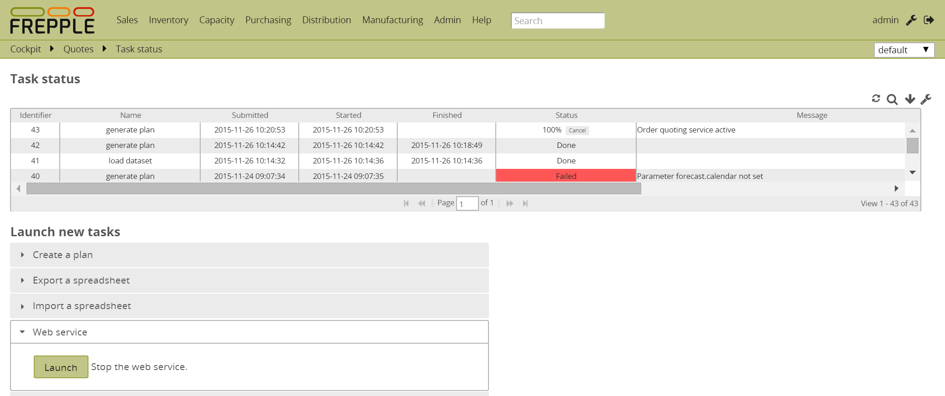

# Business processes and workflows

The order quoting process is conceptually basic, but during implementation a number of very important process and business questions need to be considered very carefully and addressed appropriately.

In this section we’ll bring up the key considerations. How these are addressed will depend on the specific business context.

From this section it should become clear the order quoting is **advanced functionality**, and implementation of this module should not be taken lightly.

## Entering of the order quotes

There are various usage scenarios for the order quoting workflows:

* **Quote creation and evaluation by the planner**  
  When the number of orders to be quoted is low, it is feasible for the planner to be the only user of the order quoting service.  
  He/she uses the order quoting service as an aid in generating promise dates for orders.
* **Quote evaluation by the planner**  
  When the number of orders to be quoted increases, they can no longer entered by the planner, but are entered by sales people or customers. This can be done in the frePPLe user interface, in the ERP system or in a web store application.  
  In this scenario, the quotes are still manually evaluated and approved by the planner. The planner will review all open quotes on a daily basis, and generate a promise date.
* **Fully automatic evaluation of quotes**  
  In this scenario the quote are entered in the ERP system or in a web store application. That front end application runs a query on the frePPLe order quoting. The promised delivery date is replied to the front end application within a second.

## **Plan release**

The order quoting service needs a stable and approved plan to work on. When the planners are still reviewing and updating some of the input data, the plan obviously can’t be used to compute delivery dates for new orders. Only when the planners approve the plan can it be used for order quoting.

There are two main ways of this plan approval:

* **Explicit approval by the planner**In this scenario the planner manually triggers the publishing of the plan. He/she launches the refresh of the order quoting service from the execution screen in frePPLe.   
  The published plan continues to be used for quoting until the next one is published. During this time the published plan is not updated with new data from the source systems (eg new inventory data from ERP).  
    
  This approach is typically used a) when the planners themselves are the main users of the quoting service, or b) when significant planner review and input is required to achieve a good plan.
* **Implicit and automatic approval**In other scenarios the order quoting service is refreshed automatically in an batch job. The batch job runs typically daily. It pulls the latest data from the ERP system, recreates the plan, and publishes the plan for order quoting.

## Treating high priority orders

The order quoting service runs an incremental plan on top of the existing orders. It effectively scans for “left-over” capacity and material.  
For high priority orders that can result in a due date that is not reflecting the desired priority.

An example to illustrate:

* Existing plan:  
   Order A of normal priority, promised for delivery on day 10

Order B of low priority, promised for delivery on day 10  
 Order C of low priority, promised for delivery on day 10

* We are now trying to promise a high priority order for delivery on day 10.  
  The earliest feasible delivery turns out to be 5 days late:  
   Order D of high priority, quoted for delivery on day 15

This answer may not be acceptable.

To overcome this, there are several options:

* Ignore the date returned by the quoting service, override it an accept the high priority order for delivery on day 10.   
  When the complete plan is regenerated, the planning algorithm will allocate the material to the high priority order and plan the low priority order late.
* Manually quote the high priority orders. The planner can regenerate the complete plan and investigate the impact on existing orders in detail. In this case the planner judges what is acceptable.
* Use some form of reservation workflow, as outlined in the next section.
* In some cases, the order quoting service may simply not be the right solution for your problem… The quoting service concept works best when the majority of the orders have equal priority and can be treated on a first-come-first-served basis.

## Reservation and allocation workflows

The order quoting treats all orders in a FIFO manner: the first orders get the first chance of reserving the capacity they need.  
In some cases you may want to reserve some material and capacity for rush orders or for important customers.   
You could also want to avoid that a single customer books all available supply by placing his order early. A customer with equal importance but who orders a bit later might then get an unfair late order.

The recommended way to resolve this kind of situations is to use a forecast. The forecast is planned and effectively reserves material and capacity. The supply used for the forecast is not available for quoting orders. When a sales order that matches the forecast (ie matching product and customer), the order will consume that forecast – and thus gets reassigned the supply that was originally planned by the forecast.

An example to illustrate:

Initial plan:  
Forecast of 0 for customer B  
Forecast of 10 for customer A  
-> During planning of the forecast this reserves capacity for 10 units on resource X and material Y.  
  
When a new order from customer B is quoted, we scan for unused capacity on the resources X and Y. The quote can’t use the material and capacity we have planned to use for the forecast of customer A.

When an order from customer A for 10 units is quoted, we can net it from the forecast and we can re-use the material and capacity planned for the forecast.

If the order from customer A would be for 15 units, we would be able to net 10 from the forecast and re-use that reserved supply. The extra 5 units are then quoted for any “left-over” unallocated material and capacity.

Depending on the business case, other approaches and variations for this reservation problem can be applied. For instance: using the release fence of operations, or a customized post-processing of the plan.

# Architecture

In the default setup the frePPLe planning engine runs in batch mode: when the user generates a plan, a separate process is spawned that runs the planning algorithm. The planning algorithm is never run by the web server process.   
Once the planning process is finished and the new plan is exported to the database, the planning engine process is shut down.

With the order quoting module, the planning engine process doesn’t shut down after planning. Instead it becomes available as an in-memory HTTP server, listening on a different port number. The order quoting screen or external systems use a REST-based API to connect to this web server, and query the plan.

The planning engine HTTP server is shut down either a) when a new version of the plan is ready to become on-line or either b) with explicit shutdown command.

# Configuration

The following extra parameters are introduced by this module.

|  |  |
| --- | --- |
| **Parameter** | **Description** |
| quoting.service_location | HTTP location of the web service, formatted as address:port.Default value: localhost:8001 |